The ISS is pressurised at 14.7 +- 2 psia. The pressure when performing space walks is much lower than the internal pressure of the space station. So essentially like in diving they are travelling up. Or reducing pressure there by increasing the volume of nitrogen within their blood streams. For this reason they need to breath a mixture of 100

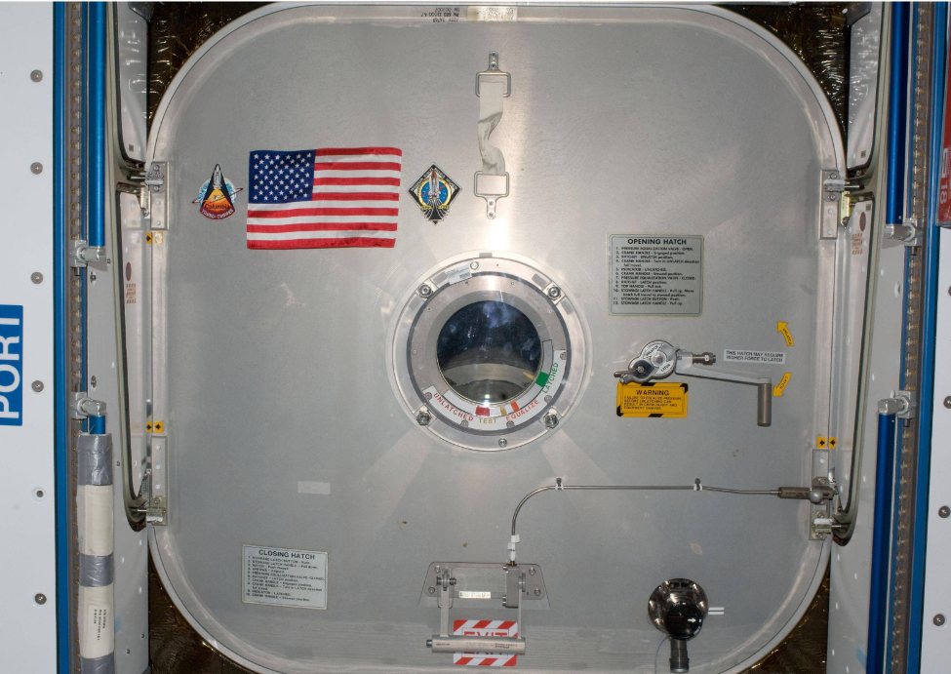

Depth calculations

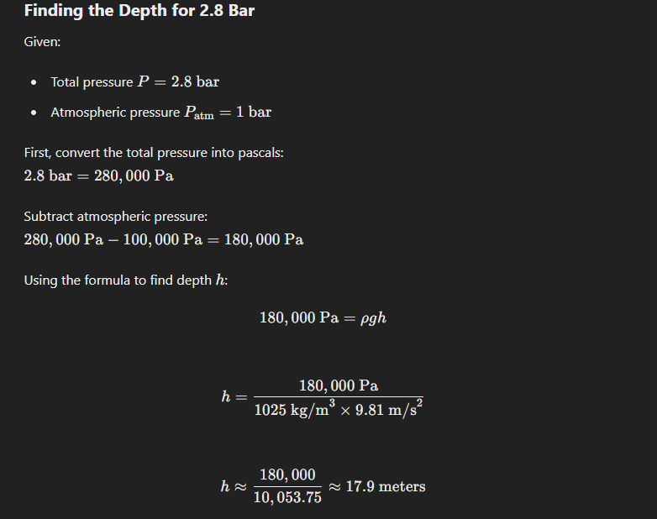

Ascent calculations, An accelerated ascent rate.
If a human body were completely free of nitrogen and assuming all technology and safety systems could handle the increased ascent rate without any issues, the theoretical speed of ascent to the vacuum of space would be determined primarily by the rate of pressure change tolerated by the human body and the internal pressure of the ISS.
<$Scr_H::3>Pressure Conditions<!$Scr_H::3>
- Internal Pressure of the ISS: The ISS is maintained at a pressure of approximately 1 atmosphere (101.3 kPa or 1 bar).
- Vacuum of Space: The pressure in space is effectively 0 atmospheres (0 kPa).
<$Scr_H::3>Ascent Rate and Tolerance<!$Scr_H::3>
- Rapid Ascent Scenario: If the ascent rate were to increase significantly, we need to consider the physiological limits for handling rapid pressure changes. With nitrogen removed, the risk of nitrogen bubbles forming is eliminated, but other factors like gas expansion and physiological stress still play a role.
- Theoretical Maximum Ascent Rate:
- High-Speed Ascent: Assuming that technology can support a rapid ascent without issues, and the human body can tolerate the transition, a theoretical ascent rate might be very high. For example, high-speed balloons and spacecraft can achieve ascent rates of up to 10 meters per second or more.
<$Scr_H::3>Calculating Theoretical Ascent Time<!$Scr_H::3>
To estimate how quickly a human could ascend to space under these ideal conditions:
- Altitude to Space: The Kármán line, considered the boundary of space, is at approximately 100 km (100,000 meters) above sea level.
- Ascent Rates: If we consider a high ascent rate of 50 meters per second (which is significantly higher than current technology allows but theoretically possible):
Time=AltitudeAscent Rate=100,000 meters50 meters/second=2,000 seconds≈33.3 minutes\text{Time} = \frac{\text{Altitude}}{\text{Ascent Rate}} = \frac{100,000 \text{ meters}}{50 \text{ meters/second}} = 2,000 \text{ seconds} \approx 33.3 \text{ minutes}Time=Ascent RateAltitude​=50 meters/second100,000 meters​=2,000 seconds≈33.3 minutes
If we increase this rate to 100 meters per second:
Time=100,000 meters100 meters/second=1,000 seconds≈16.7 minutes\text{Time} = \frac{100,000 \text{ meters}}{100 \text{ meters/second}} = 1,000 \text{ seconds} \approx 16.7 \text{ minutes}Time=100 meters/second100,000 meters​=1,000 seconds≈16.7 minutes
<$Scr_H::3>Summary<!$Scr_H::3>
Given the assumption that all technology can handle the increased ascent rate and that the human body is free of nitrogen, a rapid ascent to the vacuum of space could theoretically occur in approximately 16 to 33 minutes at rates of 50 to 100 meters per second. These estimates are based on ideal conditions and assume that no other physiological or technological limits are exceeded. In practical scenarios, safety and physiological limits would likely necessitate more gradual ascent rates.
Suit pressure considerations.
Astronauts' spacesuits are maintained at a specific pressure to balance the need for mobility and safety. The pressure inside an astronaut's spacesuit is typically about 4.3 pounds per square inch (psi), or roughly 0.29 atmospheres (30 kPa). Here’s why this pressure is chosen:
<$Scr_H::3>Reason for the Suit Pressure<!$Scr_H::3>
- Mobility and Flexibility:
- Lower Pressure for Movement: A lower internal pressure makes the suit more flexible and easier for astronauts to move their limbs. At higher pressures, the suit becomes stiffer and more difficult to manipulate, which would hinder the astronaut's ability to perform tasks during a spacewalk (Extravehicular Activity or EVA).
- Oxygen Concentration:
- Pure Oxygen Environment: To compensate for the lower pressure, the suit is filled with pure oxygen. This ensures that astronauts still receive an adequate supply of oxygen to breathe despite the lower atmospheric pressure. Pure oxygen at 4.3 psi provides the same amount of oxygen as the normal Earth atmosphere, which is about 21% oxygen at 14.7 psi.
- Decompression Sickness Mitigation:
- Reduced Risk of DCS: Before a spacewalk, astronauts undergo pre-breathing protocols where they breathe pure oxygen for a period of time. This procedure helps to eliminate nitrogen from their bloodstream, reducing the risk of decompression sickness (DCS) when transitioning from the ISS's 1 atmosphere pressure to the suit's 0.29 atmosphere pressure.
<$Scr_H::3>Summary of Key Points<!$Scr_H::3>
- Pressure Level: Astronauts' spacesuits are maintained at about 4.3 psi (0.29 atmospheres or 30 kPa).
- Pure Oxygen: The suits are filled with pure oxygen to ensure adequate oxygen supply at the lower pressure.
- Mobility: The lower pressure allows for greater flexibility and mobility, essential for performing tasks during spacewalks.
- Safety Protocols: Pre-breathing pure oxygen helps to reduce nitrogen levels in the bloodstream, mitigating the risk of decompression sickness.
This carefully balanced pressure level ensures that astronauts can move efficiently and perform necessary tasks outside the spacecraft while maintaining their safety and health.
n theory would maintaining the suit at a lower pressure aleviate a rapid decompression than if the suit was pressurised at a higher internal pressure?
ChatGPT
Yes, maintaining a spacesuit at a lower pressure could theoretically alleviate some of the risks associated with rapid decompression compared to a higher internal pressure. Here’s why:
<$Scr_H::3>Key Factors in Decompression<!$Scr_H::3>
- Pressure Differential: The greater the difference between the internal pressure of the suit and the external vacuum of space, the more forcefully the decompression will occur if the suit is breached.
- Lower Pressure: If the suit is maintained at a lower pressure, the differential between the suit's internal pressure and the vacuum of space is reduced, resulting in a less severe decompression event.
- Higher Pressure: Conversely, a higher internal pressure would mean a greater pressure differential, leading to a more violent decompression if the suit is compromised.
- Gas Expansion:
- Boyle's Law: According to Boyle's Law, the volume of a gas is inversely proportional to its pressure at a constant temperature. A lower pressure in the suit means that any remaining gases would expand less dramatically in the event of a rapid decompression.
- Risk Mitigation: This reduced expansion minimizes the risk of injuries related to gas expansion, such as barotrauma or embolism.
<$Scr_H::3>Physiological Considerations<!$Scr_H::3>
- Nitrogen Elimination:
- Decompression Sickness (DCS): At a lower suit pressure, the risk of decompression sickness is mitigated through pre-breathing protocols that eliminate nitrogen from the bloodstream. This is less of a concern if the pressure is already low, as it reduces the likelihood of nitrogen bubbles forming during rapid decompression.
- Suit Flexibility and Functionality:
- Mobility: Lower pressure suits are generally more flexible, allowing astronauts to move more freely. This flexibility can be crucial during rapid decompression, as it allows astronauts to react and manage the situation more effectively.
<$Scr_H::3>Comparative Analysis<!$Scr_H::3>
- Lower Pressure Suits (4.3 psi or 0.29 atmospheres):
- Advantages: Reduced pressure differential, less severe gas expansion, and enhanced mobility.
- Disadvantages: Requires pre-breathing protocols to eliminate nitrogen and ensure adequate oxygen supply.
- Higher Pressure Suits:
- Advantages: Simpler pre-breathing protocols, potentially more comfortable breathing environment.
- Disadvantages: Greater pressure differential leading to more violent decompression, increased risk of gas expansion injuries, and reduced suit flexibility.
<$Scr_H::3>Summary<!$Scr_H::3>
Maintaining a spacesuit at a lower internal pressure (around 4.3 psi) can theoretically alleviate some of the risks associated with rapid decompression compared to a higher internal pressure suit. The lower pressure reduces the pressure differential, minimizes the severity of gas expansion, and enhances suit flexibility, all of which contribute to a safer and more manageable situation during a rapid decompression event.

